Helping my child as they cope with Trauma and Grief

We hope that this booklet will help you to help your child during a time of trauma and grief. We have gathered resources from NEPS (National Educational Psychology Service) and Barnardos to help put this booklet together. We will cover the following topics in the booklet:
- Children’s Understanding and Reaction to Death according to age- Page 2
- Stages of Grief – Page 5
- When should I seek additional help for my child- Page 6
- How to cope when something terrible happens- Page 7
- Ways to help your child- Page 8
- Supports and services for you and your child- Page 9

- Children’s Understanding and reaction to Death according to age
We all cope and react to death differently. For children, how they understand death depends on their age and stage of development. Being aware how our child understands death according to their age group can help us, as parents, to guide them through and to also recognise if they are not coping well. This information is taken from the NEPS resource- Responding to Critical Incidents.
Children’s understanding and reaction to death will depend on their age and their developmental stage. The following are guides only as children will differ in their reactions and grasp of events for a range of reasons other than age alone.

How might my child react to death?
The following information is taken from Barnardos -Parents Coping with Death. Some children may feel all of these reactions while others may only feel a few. Between the first and second year after the death, the child may not feel the loss so acutely and acceptance of the death may settle in. Sometimes the reaction to grief may be delayed, with grief only coming to the surface several years later. Being aware of the common reactions below can help parents to see that how their child is reacting is normal and part of the grieving process. Also, as parents, showing our children that we are open and available to talk about death will give our children the space to talk about their feelings and fears. Talking will also help our children understand what has happened and to work through their worries or fears around death. Sometimes, if a parent is also grieving, it can be difficult for the parent to be open to talk about death with their child. It can be a good idea to involve the help of another family member, friend, teacher or a support service to help you and your child cope with grief.
- Stages of Grief
This information is taken from NEPS-Responding to Critical Incidents.
Grief is a normal and healthy response to loss. Although there are distinct phases in the grieving process, people experience these phases differently and at different times. Generally, the grieving process in adults is thought to take about two years, while with children and adolescents it may be over a longer period with the child experiencing varying stages of grief as they reach different developmental milestones.
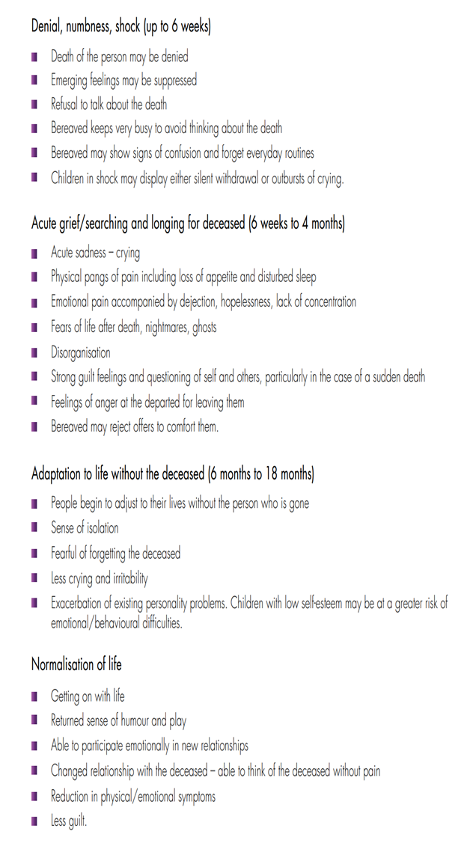
- When should I seek additional help for my child?
In the following instances it is a good idea to seek additional help for your child. Express confidence in your child’s ability to get through this difficult time and show hope for the future. See the supports mentioned at the end of this booklet to guide you. Information also from Barnardos.
• If a teenager is having reactions to a death that is interfering with their ability to carry on their daily routine or experience the different stages of grief. Some children might get ‘stuck’ on the traumatic way the person died and not be able to process their grief.
• If a teenager’s behaviour undergoes a dramatic change such as isolating totally from friends, staying in their bedroom, and/or are complaining about aches and pains which have no medical cause.
• If a teenager witnessed or survived an event which resulted in another person’s death, like being in a car when an accident occurred or seeing the fight which resulted in someone’s death.
• If a teenager is still reacting in a way that indicates they are troubled by memories and thoughts (nightmares, sleep disturbances, restlessness and excessive activity, for example), withdrawing from others, avoiding anything that may remind them of what happened, or showing reactions which indicate an almost constant sense of danger (they are always on guard, are excitable, irritable and so on). They may be experiencing physical symptoms such as tummy aches, headaches, racing heart.
• If strong or overwhelming feelings continue with the same intensity over time. These might be anger, guilt, shame over the traumatic death. The child might be blaming themselves, not be able to trust anyone, believing the world is unsafe.
• A complete absence of feeling or emotion or a strong sense of ‘going blank/ blanking out’ can also indicate a traumatic response which a teenager may need professional help to understand and manage.

- How to cope when something terrible happens
The following tips are for the child or teenager going through a traumatic event. It can be a good idea for the parent to sit down and go through these with their child. These tips will allow the child to see that it is ok to go ahead with their normal routine, to have fun and to also become upset and cry. This information is also taken from NEPS.

- Ways to help your child through a difficult time
It is very hard, as a parent, to see your child going through a difficult time. It is also hard to know what to do in these difficult situations. Be confident that you are already showing your love and support to your child. They know that you are there to help and support them in any way they need. The following are some tips, also taken from NEPS, which show ways to help your child.

- Support Services
- Barnardos- offers support services for children and families. Phone the Clonmel office on 052 6170665. Barnardos also have a bereavement support service, call 01 4732110.

- Foroige- Foroige is a youth organisation who work with young people from 12-18.
Contact details (Youthwork programme):
Sheridan Brady Tel. 086-384 8160 E-mail: sheridan.brady@foroige.ie
Contact details (Family Support)
Siobhán Clifford Tel. 086-833 1866 E-mail: siobhan.clifford@foroige.ie

- HSE Psychology Drop In Clinic- the psychology drop in clinic gives access to a psychologist to offer advice to a parent on their own or with their child. For the Waterford service phone 051 842 982 and the Tipperary service phone 052 617 7911.

- CAMHS (Child and Adolescent Mental Health Service- speak to your GP for referral to CAMHS

- Samaritans- helpline available 24 hours a day to those in need of support. Call 116 123.
- Childline- a support service for children and teenagers. Call 1800 66 66 66 or text 50101.
- Nano Nagle resource centre – offers counselling for adults and children from the age of 12 Call 051 642418
- Rainbows – To support children & young people affected by loss because of bereavement, separation or divorce. 01 4734175 rainbowsireland.ie

Useful Websites
- www.barnardos.ie The Barnardos website has a great range of resources for parents including their free Parenting e-books.
- www.childhoodbereavement.ie The Irish Childhood Bereavement Network have a lot of resources about bereavement on their website.
- www.jigsaw.ie A website for young people with a lot of helpful resources and online support.
- www.tipperarychildrenandyoungpeopleservices.ie for details of the range of services available in South Tipperary.
- www.CYPSE.ie Tipperary Children and Young Peoples Services Committee (CYPSC)

