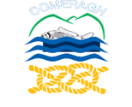

**The CCN**

**Comeragh College Newsletter**

ST TERM 202 **02**

**Happy Holidays**

**Saoire Shona, Buona Vacanza, Joyeuses Vacances, Frohe Feiertage, Feliz Fiesta.**

Under the direction of Mr B. Gallagher, a motivated publishing team consisting of Joanne Burke, A.J. Diffily, Anna Doyle, Charlie Finn, Joe Houlihan, Lauren McNamara, Michaela Phelan, Zuzanna Rudzik, Lorcan Sullivan, Kain Waters and Saoirse White led the effort to bring this newsletter together.

**PRINCIPAL’S ADDRESS**

Christmas 2020 is almost here!

I am very aware that the past nine months have been demanding to say the least. But we have all risen to the challenges presented to us and we have overcome them through a hugely united collective effort. In fact, I am very proud of our students as you have shown great maturity during the March-June school closure period and you have been extremely understanding and positive during this Covid-19 dominated term.

I also want to express my gratitude to the parents/guardians and families of our students here at Comeragh College. Your support to the school has been unwavering and for that I say thank you.

As principal of this school, which will reach the 500-student mark for 2021/2022, I am delighted to take this opportunity to wish every member of our school community a happy and safe Christmas.

Enjoy reading this newsletter and more importantly enjoy the well-earned break and I look forward to January 2021 and the term ahead.

Best wishes,

Kevin Langton,

Principal

**SCHOOL CHRISTMAS RAFFLE**

SCHOOL CHRISTMAS RAFFLE

****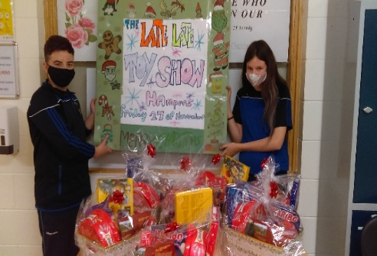**THE SCHOOL’S “LATE LATE CHRISTMAS TOY SHOW RAFFLE” Was Held on 27th November.** Congratulations to all the winners…

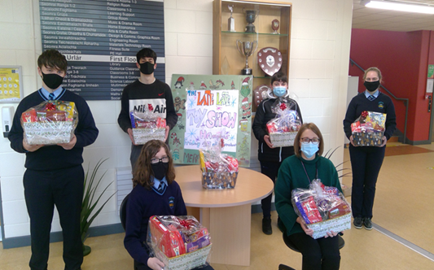

***Artwork & poster completed by students pictured (left). Fantastic job!***

Comeragh College students and Ms. Jensen, Comeragh College. Congratulations to everyone.

WELL DONE PAST PUPILS

**WELL DONE TO OUR PAST PUPILS**

Well done to all students who completed the Junior Certificate & Leaving Cert exams this year. A fantastic achievement by any national standards. Congratulations to everyone involved. Best of luck to everyone in your future endeavours. Also, a big thank you to parents and guardians, who supported your children during their time in Comeragh College. Likewise, to the dedicated and talented school staff who put in so much effort for the pupils to achieve their full potential. Congratulations to everyone who has moved on, either in their studies or to start new careers in their chosen paths in life, be it University, College, training courses, apprenticeships and working lives. Academic success matters, but it is only part of the bigger picture. Well done to all!

**WELCOME TO ALL OF OUR NEW PUPILS**

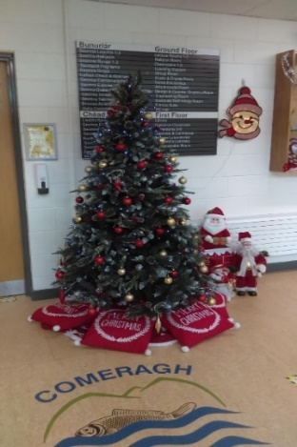WELCOME TO ALL OUR NEW PUPILS



We would like to welcome all our new pupils in each year to Comeragh College, especially to the 1st Year students who are just starting off on their path into second level education. Also, a warm welcome to all the international students and new students who joined us in the upper years of the school. We are sure you will all enjoy and benefit from your time here.

First Years: A very special welcome to you all. We will include a year photo and names when circumstances allow in the next issue. In the meantime, we hope you enjoy your time with us. Happy Christmas 2020, and enjoy your well-earned break. Be good.

**WELL-BEING RAFFLE**

WELLBEING RAFFLE

A big congrats to the ‘Well-Being’ raffle winners. We had a winner from every year in the school this year. There were some great prizes won, and we are sure that everyone will enjoy their prizes very much. A great start to the Christmas Festive Season. **Happy Christmas Everyone.**

**COVID-19 CARE**

COVID – 19 CARE

As everyone is aware, we are all going through an unprecedented time of uncertainty and change. Safety in school for all pupils and staff is a priority for us all. The school has initiated a mandatory programme of Health and Safety to maintain the health of all in our school. This involves the wearing of face masks, using hand sanitiser facilities and following health and safety instructions from staff. This is for ALL OUR SAFETY. We will get through this with the help and cooperation of all involved. Thank you.

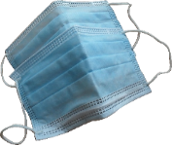

[This Photo](https://pngimg.com/download/93000) by Unknown Author is licensed under [CC BY-NC](https://creativecommons.org/licenses/by-nc/3.0/)

**OUR SCHOOL MOTTO**

SCHOOL MOTTO

“Ceim is Ceim” – “Step by Step”. We in Comeragh College value the development, both academic and personal, of all pupils in our school. We continue to nurture the growth of all students during their years in Comeragh College, step by step, and help them to deal with challenges they may face during their time in our school. We prepare them for life both during and after school. During times of personal and social challenges, it is important to remember that there is ALWAYS someone to talk to, a friend, a staff member, or classmates – as a school we pride ourselves in this.

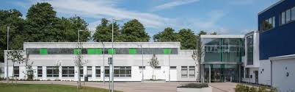SCHOOL DEVELOPMENT

**SCHOOL DEVELOPMENT**

**OUR VISION**

We at Comeragh College have the highest ambitions and expectations in all aspects of school life and strive to nurture these qualities in every student. Our young people are treated as individuals and we are strongly committed to equality of opportunity. We want all students to achieve their potential both academically and socially so that they leave here with the widest range of choices open to them in a changing society.

Here at Comeragh College we offer a huge range and variety of subjects at both Junior and Senior Cycle levels. Practical areas, the Arts and Sciences, Music, Sports and Wellbeing are only some of the areas covered by the curriculum. In addition, there are many extra-curricular activities on offer, both during school time and after school. We ensure that all pupils experience as much of a full school life as they can during their time with us. We ensure that we have programmes to suit all students, and we have a range of pastoral and special educational supports for students who may need them during their time with us.

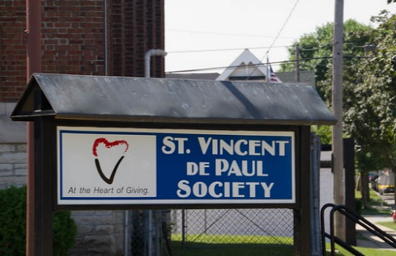We have some of the best facilities, both school and sports wise, for our students. Being a modern and purpose campus, built for the sole purpose of education, students can benefit from modern and dedicated amenities. Modern classrooms, practical and technology rooms, sports facilities including pitch, gym, internal and outside courts, walkways, and outside social areas. The school location is centrally near enough to be convenient for students yet independent enough to work away as an educational facility. An increase in staff has meant that we can provide more individual attention for students, a wider range of subjects and educational programmes that suit specific pupils (JCPA, JC, LC, LCAP, TY to name a few), and specialised programmes for pupils with additional educational needs. Students best learn through engagement and active learning which is the proven and most effective way. We have Year Directors, class teachers, Guidance Counsellors, Home School Liaison teachers and Support Teachers for those who may require them. Students regularly fundraise for good causes and give back to the community in so many ways also.

Numbers in Comeragh College have been increasing year on year, including this year, and for the next academic year 2021-2022. This is a result of our success, development, and proven achievements here in the school. Again, there was a huge number of enrolment applications, via mail and for the first time using the online process. This was a huge success both in environmental terms and for being friendly and convenient for parents / guardians to use. To us, every student matters.

R CANTEEN AND FOO

**OUR CANTEEN AND FOOD**

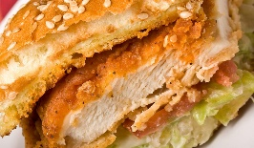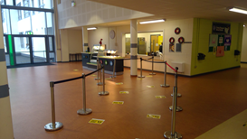The school canteen is a fantastic facility to have in our school and it keeps us all going in the cold winter mornings and long summer evenings. Healthy and hot food is provided for all students every day with a selection of drinks on offer too.

**Small Lunch:** Hot rolls, Chicken fillet or sausages, rashers, salad, fruit, water, juices, cookies, scones. Fruit is also available to all for free.

**Main Lunch:** Ham/cheese Pizza; Goujons/ Sweet Chilli Chicken wraps and paninis. Also, pasta; bacon; cottage pie, sweet and sour; beef lasagne – for €2, and €1 for a drink. Fruit is free and a very healthy option. A key FOB is available from the school for those who would like to prepay for lunches. This is very convenient and handy for all students.

Thanks to the ladies who keep us all going during the school day, Margaret, Paula and Evelyn.

A STUDENTS INSIGHT: Living & Coping with Covid-19. by Saoirse , TY.

**A STUDENTS’ INSIGHT: LIVING AND COPING WITH COVID-19**

A TY students’ insight into COVID-19 and coping mechanisms that may help. The staff at Comeragh College and BAM have put in a lot of effort making changes across the school to help maintain Covid-19. Students may have found that things are a lot different this year, for example, different entrances for each year, masks are now mandatory, social distancing has been implemented and hand sanitizing is recommended when entering or leaving the classrooms. Due to these changes, it is understandable that students are struggling to adapt. Especially for first years, who are in a completely new environment. During quarantine, a lot of us picked up coping mechanisms, like going for a walk, drawing, painting, reading a book, playing a sport, or listening to music. It is very important to keep these coping mechanisms up to help us get through these rough times. Stay safe. By Saoirse T.Y

**THE STUDENT COUNCIL**

THE STUDENT COUNCIL

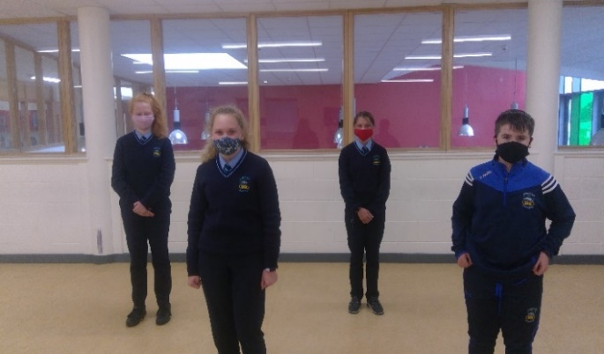1st year reps: Congratulations to this year’s first year class reps on joining the Student Council. Best of luck in your new roles. It is a great responsibility to be elected to represent your fellow students

2nd year reps: Mia Murphy and Danny Walsh.

4th year reps: Charlie Finn and Abbie Earl.

5th year reps: Tadgh Sheehan, Lorna O’Neill, Jade Keevan, Artjoms Sergejs

6th year reps: Darragh O Sullivan, Scott Stewart, Nicole Vaughan, Eve Keane

**STAFF INTERVIEW WITH MS. KELLY**

INDEPTH STAFF INTERVIEW

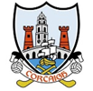The following is an interview carried out with staff member Ms. Kelly, Comeragh College, and All-Ireland Semi-Finalist on the week of her All-Ireland Ladies Football Semi-Final match versus Galway, 6th Dec 2020. The interview was carried out by Transition Year students Michaela Phelan, Saoirse White and Anna Doyle

**Q: Your sporting hero when you were 10? Q: Your sporting hero now?**

My Cousin Norita Kelly, she played for Cork. Katie Taylor

**Q: What other sports have you played? Q: Sporting career highlight…**

Handball, camogie, and basketball Winning the All Ireland in 2016

**Q: One rule change you would make to your sport? Q: What do you do to relax?**

That you can shoulder I go for a walk or watch television

**Q: Biggest frustration with your sporting career or your sport?**

All the time it takes up between training and matches.

**Q: What do you do to prepare yourself for a big game?**

Listen to pop/dance music. Eat and sleep well. Avoid reading articles about the match. **We want to wish Ms. Kelly the very best of luck in the All-Ireland Ladies Senior Football Championship final between Cork and Dublin.**

SPORTING ACTIVITIES COMERAGH COLLEGE:

**SPORTING ACTIVITIES IN COMERAGH COLLEGE**

Comeragh College has excelled in many areas of sporting life, in numerous sports and inter-school competitions. We aim to keep up this high level of achievement in our school*.* **2020-2021** training has commenced in most sporting activities after school which include hurling, football, basketball, and athletics. Despite being hindered by Covid-19 restrictions we are doing our best to provide training and activities to all pupils who wish to become involved in school sports. It is a fantastic experience to be able to represent your school in any sport or extra-curricular activity, and we have plenty to choose from here in Comeragh College. We have an extremely talented and dedicated range of *qualified sports coaches* and *inter-county players* from all levels, who provide students with the opportunity to develop and improve their team and individual skills. Our school trophy cabinet in the front hall is a small sign of our successes over the years. Who knows what future stars we may have amongst us? Come on everybody, join in and give it a go, you might be surprised!

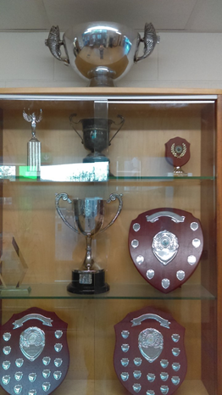**CURRENT SCHOOL ACTIVITIES TIMETABLE:**

* **Monday 3.50pm Senior Boys Basketball (3rd-6th year) and**

**1st & 2nd Girls basketball**

* **Tuesday 3.50pm Walking/running Club & athletics.**

**Camogie all groups**

* **Wednesday 3.50pm Senior Girls Basketball (3rd-6th Year)**
* **Thursday 3.50pm Ladies Football (All year groups).**

**Boys hurling. 1st & 2nd year boys’ basketball**

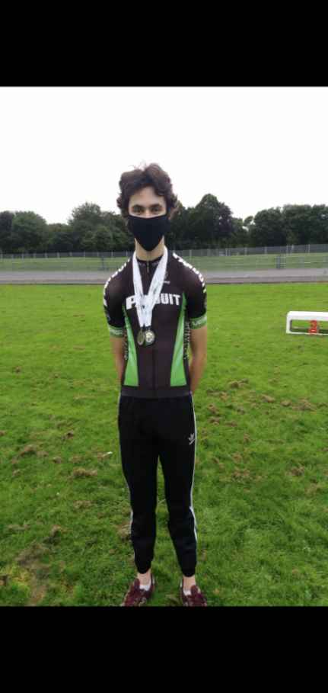\**Soccer coming soon*

*\*Soccer and Basketball Tournaments started December, 2020*

*Congratulations* to 6th Year student Patrick O’Loughlin on his fantastic and well-deserved achievements in the Junior Track National Championships, which were held Saturday 12th of September, on an outdoor track at Sundrive Velodrome, in Dublin. Patrick took part in eight races, consisting of qualifiers, semi-finals, and finals. He came away with 3 All IRELAND medals. A fantastic achievement under any circumstances.



* Silver in the Scratch race
* Silver in the Sprint
* Bronze in the Time trial

Once lockdown was lifted towards the end of the Summer holidays, Patrick won two Munster Road medals. Well done to a future budding star in our midst.

Comeragh Suite News

**COMERAGH SUITE NEWS**

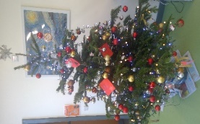Comeragh Suite staff and students would like to wish a Happy Christmas to everyone. Students have been busy around the school with schoolwork and planting the garden. We would also like to pass on a big THANK YOU to all the staff who come and give a hand with all activities in the Suite (from Minecraft to basketball, personalised physical exercise programmes to Friday mornings much vaunted student-led music & dance sessions). The Comeragh Suite students are reaping the benefits of this tuition and we hope those teachers are too. We now look eagerly to a couple of weeks break over Christmas to recharge the batteries and launch into January with renewed gusto. And further into the future, planning is already underway for Autism month in April. “***Merry Christmas to all.”***

SPECIAL EVENTS SECTION

**SPECIAL EVENTS SECTION**



Due to current guidelines many of the school special events have been postponed, but we hope to resume these as much as possible as soon as we can. Comeragh College has always prided itself on the success of these events both in school and in the community, and we will continue to do so.

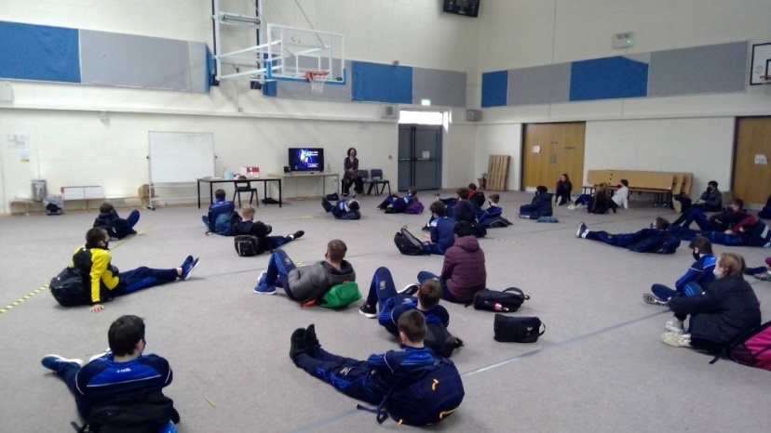We have still managed to have some guest speakers visit, covering the areas of “On-line Safety”, organised by Ms Grant, and “Substance and Addiction”, organised by Mr Breen. Both events were greatly appreciated by staff and students alike. The safety of all our pupils is a main aim for all staff at Comeragh College.

**Maureen Griffin:** On-line safety talk, Tuesday 10th Nov. 2020 Comeragh College (see left). Key issues spoken about included: Technology in bedrooms and the impact on sleep; rules regarding taking pictures/videos in school; impact of online exposure on mental health; screen time and alternatives to spending time on-line. This was Maureen Griffins second visit to Comeragh College.  She spoke to all Junior Cycle classes over the course of the day. Everyone really enjoyed the talk and benefitted greatly from a more in-depth look at on-line safety. An important and relevant topic to us all. Thank you to Ms Grant for organising this event.

**Roger Mehta** gave a very interesting talk on all areas of addiction and substance use. He is an internationally known expert in all areas to do with addiction and substance misuse, and we were very fortunate to have Mr Breen arrange this presentation day with our pupils. Feedback was very positive from all students, and everyone took something from this talk which was the main aim of staff involved in organising it. Well done to all involved, especially Mr Breen who put the event together.

On Tuesday 17th November, an online talk from **Mr. Thomas Byrne TD**, was given. This talk was arranged by Mr. Lonergan and was a great success. There was a mixture of students from both 5th and 6th Year who attended the talk, given by Minister of State for European Affairs, Thomas Byrne. The topic of the talk was careers in European Institutions and the importance of having a 2nd and 3rd language. Thanks to Mr. Lonergan for co-ordinating this online experience for all students.

On Thursday 19th November, the school held a **virtual open evening**. It was a tremendous success. This was an extremely impressive and very informative, well organised, well presented evening, with great participation and feedback. Video and power-point productions were particularly well received, and well worth the amount of effort and time involved. The great reputation and hardworking staff and students of Comeragh College, and its fantastic modern educational and sporting facilities, were very much enhanced. As were our student achievements and campus life. We hope everyone enjoyed and benefited from the evening. It shed a great light on our school, and shows why the numbers, achievements and reputation of Comeragh College are growing steadily every year since its opening.

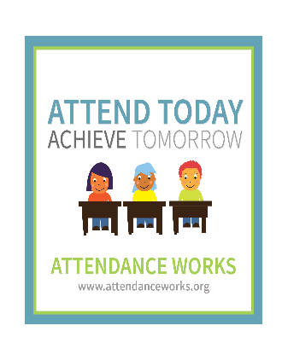**The school awareness week.** That time of year again! School awareness week ran from Monday 22nd November to Friday 26th, and was co-ordinated by Ms. Jensen. Our Career Fair, for obvious reasons, did not take place but we still wanted to focus our students on the opportunities ahead of them in the world of work and education. This year focused on the transferable skills that students learn in our academic subjects and how our school helps to prepare them for college and work, whichever path they choose to take. The main idea of the week is to get students talking and thinking about college and careers. Well done to all involved, and a special thanks to Ms. Jensen who organised this week of reflection.

**STAFF INTERVIEW WITH MR. RYAN**

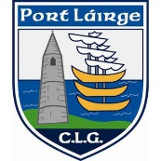INDEPTH STAFF INTERVIEW

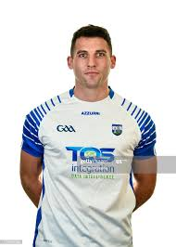The following is an interview carried out with staff member Mr. Ryan, Comeragh College, and All-Ireland Senior Hurling Finalist Vs Kilkenny 2020. The interview was carried out by Transition Year students in Comeragh College

**Q: Your sporting hero when you were 10? Q: Your sporting hero now?**

Ken McGrath . Katie Taylor

**Q: What other sports have you played? Q: Sporting career highlight**

Gaelic and soccer Captaining County final win.

**Q: One rule change you would make to your sport? Q: What do you do to relax?**

Two-point side-line I go for a swim and listen to music

**Q: Biggest frustration with your sporting career or your sport?** Injuries.

**Q: What do you do to prepare yourself for a big game?** Listen to music and cycle to prepare.

**We want to wish Mr. Ryan our congratulations in having reached the All-Ireland Senior Hurling Final Vs Limerick 2020.**

**PARENT CLASS**

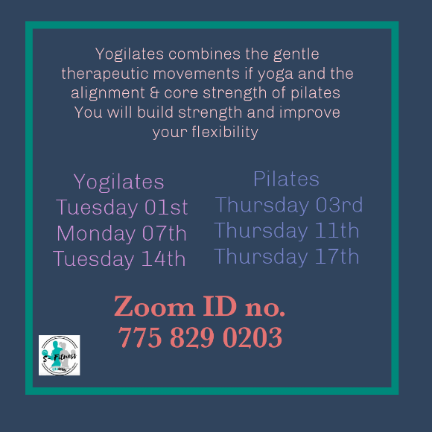PARENT CLASSES

For all the budding fitness people out there, Yogalates notice for those who would like to get fit and healthy and add a great exercise programme to your keep-fit regime. See relevant information here to the left.

**“Hot Chocolate Anyone? “**

TY students, Joanne, Lauren and Zuzanna are hosting a hot chocolate day on Monday 21st December for the students and teachers of Comeragh College. \****20c discount if you bring your own cup!***



* Hot chocolate with only cream €2.00
* Hot chocolate with marshmallows and cream €2.50
* Plain hot chocolate €1.50
* Hot chocolate with only marshmallows €2.00

On Monday, if you are interested in buying a cup, there will be a timetable made for teachers/ Year Heads. Please respect the Covid-19 guidelines when lining up. All support would be very much appreciated! Thank you. 😁

SCHOOL ACTIVITIES & TRIPS TY.

**SCHOOL ACTIVITIES AND TRIPS**

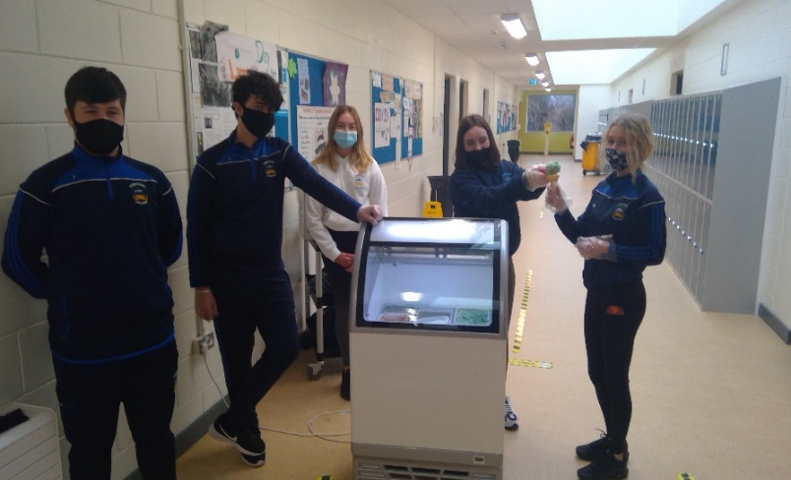TY students during their ice-cream sale in aid of Saint Vincent De Paul December 2020. A great event and a generous amount of money was raised from students and staff who contributed to this very worthy cause. Well done to everybody involved.

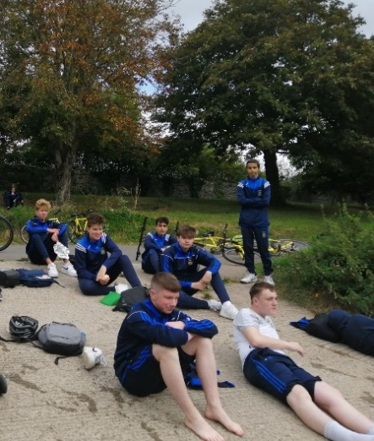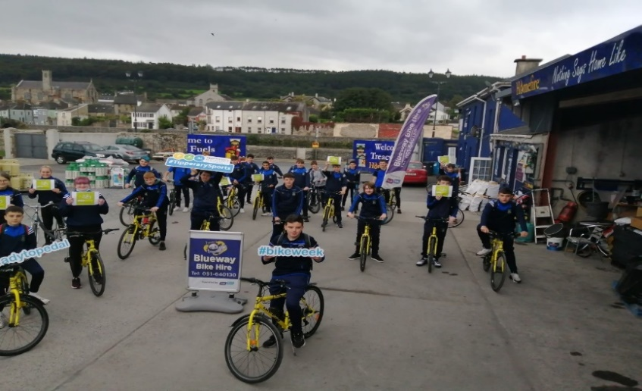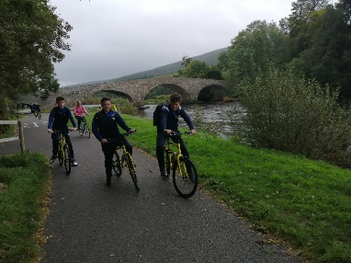The school usually has a huge mix of trips, excursions, sporting and educational activities and events going on. Unfortunately, many are currently on hold due to Covid-19 restrictions. These will resume when restrictions allow. The school is endeavouring to continue these activities as much as possible, and staff and students alike are looking forward to the full resumption of them all. We will keep parents/guardians and pupils updated on all areas

Mr Breen did manage to break out into the wild with TY students early in the year, and they had a beautiful day for it. Early one morning a group of students and Mr. Breen ventured out and took on what the Blue Way could throw at them. Little did he know of the resilience of this bunch of Comeragh College adventurers. A fantastic day was had by all, and students are eager to trek out again. A great day was had by everyone, and one of many to come. This TY group are a fantastic group, and can turn their hand to anything when needed. The future looks bright for them all.

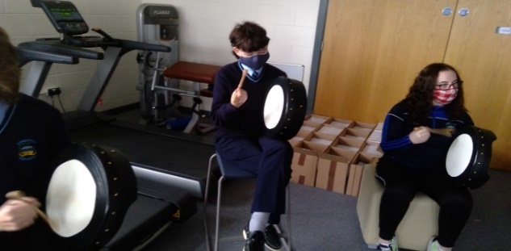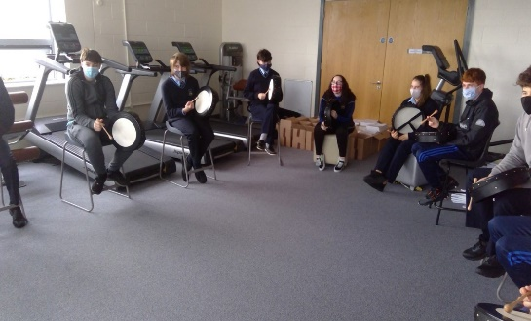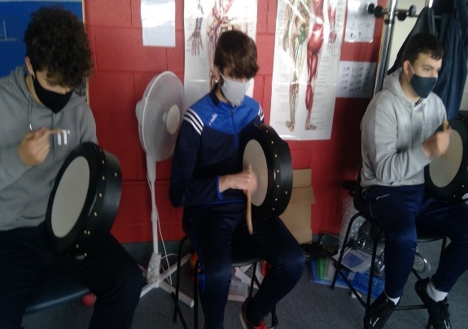Some of the TY students also took part in a Trad Session music workshop. A great experience, as you can see from the intense concentration on the faces of some of ourpossible future musicians.

“Trad gone Mad”

**JERSEY DAY**

ERSEY DAY

Jersey Day for the entire school was held on Friday 11th December, with funds going to support mental health supports which is a very worthy cause, and supporting well known local charity groups. There was a fantastic array of jerseys on show, some familiar and some very unusual. Everyone was supporting their club and county and province. A great day in the school, with some competitive elements coming out amongst staff and students. With many All-Ireland players from the staff and student bodies, the stares and loyalties were obvious.

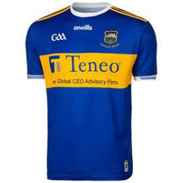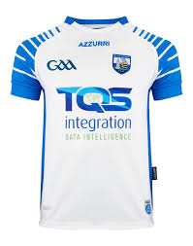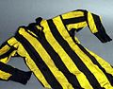  

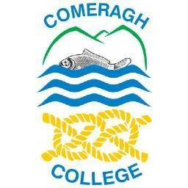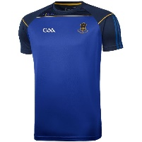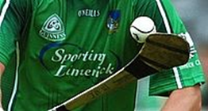 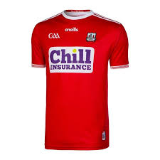



DROP OFF & COLLECTION

**DROP OFF & COLLECTION**

A small reminder for all when approaching the school grounds to be careful when dropping off and collecting pupils. There are a lot pedestrians and vehicles around at these times, so extra care and attention is needed when driving or walking near the school.

**SCHOOL BUSINESS ENTERPRISE**

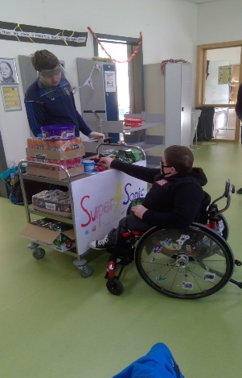SCHOOL BUSINESS Enterprise :

Darragh, working on his business enterprise mobile shop, which was called “The Super Sonic Sweet Shop “. Darragh had a great supply of goodies for sale to both staff and students alike this year. He and his fellow business entrepreneurs roamed the corridors of Comeragh College selling their treats. The business involved customer research, stock control and sales. It was a credit to the staff and students involved. Needless to say, a good profit was made!

This was a great success as part of Mr. O’Keefe’s TY Business Enterprise Project for 2020-2021. Well done to all involved. A lot of effort was put into setting up this business project and the students were able to earn a handsome profit for their work. Congratulations to all involved. Another Comeragh College future entrepreneur in the making.

**TAKE A LOOK!**

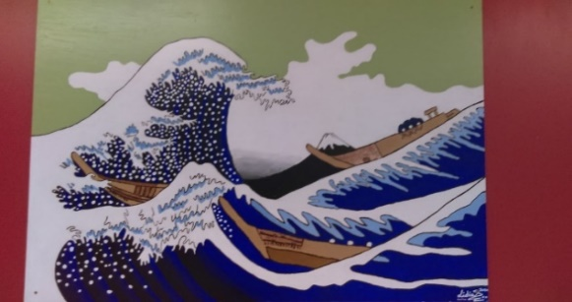TAKE A LOOK !

Placed around the school are some amazing works of art produced by students in the Art Department. Sometimes we walk past these and do not stop to look and take them in. Try it! It is well worth the time to do this and see the wonderful works of some of the very talented and gifted students that are amongst us.

***Who knows where this inspiring piece is hanging in the school…….?***

**SCHOOL CALENDAR REMINDER**

SCHOOL CALENDAR REMINDER

**School Christmas holidays are from Wednesday 23rd December to Tuesday 5th January inclusive.**

**Have a wonderful and SAFE break everybody.**

**Happy Christmas 2020**

**From All staff in Comeragh College.**

**and A Happy New Year.**