Parenting group programmes in County Tipperary: information sheet
This document provides summaries on the following parenting group programmes which are delivered by different agencies in Co. Tipperary:
- Incredible Years Parenting Programme
- Parents Plus
- Common Sense Parenting
- Positive Parenting for Changing Families
- Parenting through Art (Adlerian)
- Partnership with Parents (Barnardos)
- Family Caring Trust parenting programmes
- Non-Violent Resistance programme
- Strengthening Families programme
- Make the Connection
- Triple P – Positive Parenting Programme

The Incredible Years Programme
The Incredible Years (IY) Parenting Programme offers practical and positive support, advice and information to parents, carers, guardians of young children aged 3 to 8 years. It operates as a group programme – the Preschool Early Childhood BASIC (3-6 years) & School Age BASIC (6-8 years) - and on a one-to-one basis, the Home Visiting Coach programme.

- Parents learn various strategies to help children regulate their emotions, to improve their social skills, and to do better academically. It can also mean a more enjoyable family life.
- In the group programme, parents meet as a group with two trained facilitators. They are given opportunities to collectively and individually develop new ways of managing their children and working together in partnerships.
- Group aspects include: setting personal goals, role play practices, self-reflection, facilitator feedback, and home or classroom activities. Facilitators use video scenes to encourage group discussion, problem-solving and sharing of ideas. Parents and teachers are given handouts, activities to practice with children, and reminder notes to put on their refrigerator or blackboards.

- IY Home Visiting Coach programme: one-to-one programme with parents in home setting.

- The IYP programme is an evidence-based programme. It is one of the few ‘model’ programmes designed to directly tackle the issue of emotional and behavioural difficulties in children. It has been subject to independent rigorous evaluation, which has produced scientific evidence of its long-term effectiveness.

More info on the Incredible Years Programme at: http://incredibleyears.com/programs/
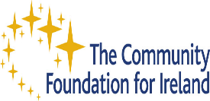

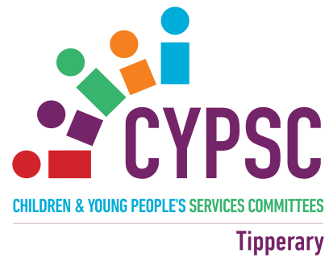

Parents Plus is a parenting programme developed in Ireland by Professor Carol Fitzpatrick, Dr. John Sharry and other Irish professionals in the Mater Child and Adolescent Mental Health Service. The Parents Plus programmes are practical and positive evidence-based parenting courses, using video input to support and empower parents to manage and solve discipline problems, promote children’s learning and develop satisfying and enjoyable family relationships. There are now 3 programmes aimed at different age groups: Parents Plus Early Years Programme (1-6 years), Parents Plus Children’s Programme (6-11 years) and Parents Plus Adolescent Programme (11-16 years).

Independent robust evaluation has shown that the programme is effective in reducing behaviour problems in children, reducing parental stress and achieving high satisfaction from parent.

Web-link: http://www.parentsplus.ie/programmes-about/

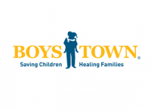
Common Sense Parenting is an evidence-based parenting group programme which provides logical strategies and easy-to-learn techniques to address issues of:
- Communication
- Discipline
- Decision-making,
- Relationships
- Self-control
- School success
The programme envisages the parents as being best-placed to teach:
- Social skills to their children as the key to helping them find success at home, in school and in other settings;
- Consequences for positive / negative behaviour;
- Self-control
The programme incorporates research-proven childcare methods, derived directly from the U.S.-based Boys Town Treatment Family Homes programme, and adapted for use by parents in the home.
For more information, go to the web-link: http://www.boystown.org/documents/csp/1101-02513e_National_CSP_ NRI_OneSheet.pdf

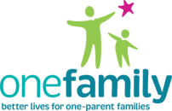
Positive Parenting for Changing Families: Building Stronger Relationships and Managing Difficult Behaviours
This parenting programme has been developed by One Family, Ireland’s national organization for one-parent families. It aims to provide parents with a toolkit of skills that enable them to help their children to successfully make their own way in the world. Building on their existing skills, parents participating in the programme learn:
- to explore the needs of children and reasons why they misbehave
- different techniques to handle difficult behaviour and how to actively listen to your child
- ways to deal with situations like family change, bullying, fussy eating and much more.
The programme has been evaluated. For more information: https://onefamily.ie/?s=Parenting

The ‘Parenting through Art’ programme, devised and delivered by Marian Clarke, Senior Art Therapist, combines Art Therapy and Adlerian principles for Democratic and Respectful parenting. Parents learn ways through Art & Play about how they can:
- give their children positive encouragement
- help their children to develop the 4 Cs: to feel connected, capable, courageous when facing challenge, and counted ( the sense that his/her contributions make a difference)
- introduce a democratic family model into their home by negotiating family agreements and logical consequences where children learn from their actions about taking responsibility.
For more information on Adlerian parenting techniques: http://www.lifematters.com/step.asp

Partnership with Parents
Partnership with Parents is a one to one parenting programme delivered in the family home. The programme can be tailored to meet the specific needs of parents and their children. It is a parenting programme devised by Barnardos and is underpinned by an extensive review of parenting literature.
The programme consists of 6 ‘plug in’ components:-
- Relationships – aims to develop the parent-child relationship
- Behaviour – supports parents to manage their child’s behaviour
- Social – explores the parents role in promoting their child’s social development
- Routines – helps parents introduce child-centred routines into their lives
- Education – helps parents consider their role in supporting their child’s education
- Physical – helps parents understand their role in supporting their child’s health, nutrition and physical activity.
There is a specific programme also available for parents with a child under 18 months old

Family Caring Trust parenting programmes:
Helping Families to Help Themselves
Family Caring Trust is a Charity founded in 1986 to support and empower parents by providing practical, skill-based resources to improve family relationships.
Courses developed by the Family Caring Trust are eclectic, not rigidly tied to any one system but drawing on:
- Adlerian psychology(goals of misbehaviour, discipline through natural and logical consequences),
- Bowen Family Systems (emphasis on changing self, not others, growing in self-differentiation and becoming a more non-anxious presence, also on reinforcing change by withdrawing attention from the more symptomatic elements in the family system and focusing on the more influential elements),
- Reality Therapy (negotiating and conflict management within the family),
- Re-evaluation Counselling (importance of parents working on their own childhood distresses and internalised oppression, value of tears, of play, and of expression of feelings), and
- Person-centred Counselling (active listening, expressing needs and feelings in "I" messages).
While there is a clear focus on improving communication within a family, there is also emphasis on change - changing the power basis and decision-making balance within the couple relationship and between parents and children.
All independent evaluations to date have been positive about the user-friendliness of the courses and the beneficial effects on the family life of participants.
For more information, follow the web-link: http://www.familycaring.co.uk/
For more information, see website: http://www.familycaring.co.uk/
_______________
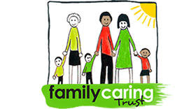

NON-VIOLENT RESISTANCE PROGRAMME
The goal of the Non Violent Resistance Programme, adapted for use in Ireland, is to assist practitioners to provide parents with the skills to use when they experience Child to Parent Violence in their home. It is a brief, systemic and cognitive behavioural response to child to parent violence. The NVR Programme is another tool in the practitioner’s tool box in their work with families and parents that complements their already existing skills, values and knowledge. Working through the practitioner, the NVR Programme aims to empower & support parents/ carers in preventing & responding to the controlling and violent behaviour of children and teenagers.
____________________

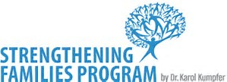
The Strengthening Families Programme is a USA evidence- based family skills programme held over 14 weekly sessions aimed at parents and their teens aged 12 - 16 years. The programme was first created in 1982 by Karol Kumpfer, Professor of Health Promotion and Education, University of Utah as a programme for 6-11 years and has since been adapted to other groups, including the 12-16 years.
SFP aims to provide families with the skill sets needed to respond to life situations. These programmes run in areas that have been identified as disadvantaged and support the justice system and social work system with their client base. Due to the social learning format of the sessions and the knowledge gained by facilitators in handling difficult client base we believe that continued delivery of these evidence based programmes will continue to support and improve the quality of life for the most marginalised in society.

This family skills training programme has been found to significantly improve parenting skills and family relations. It supports the family in reducing problematic behaviours in the home. The SFP is one of the most powerful programmes for family change in the country as it involves not just the parents or the children alone but the entire family unit. The SFP is unique in this respect among parenting and family programmes as it was developed specifically for children of alcohol and drug abusing parents.

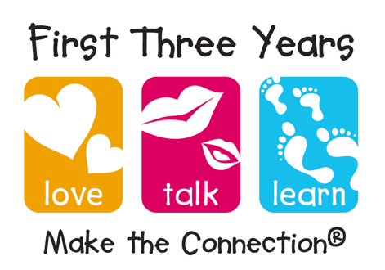
The Psychology Foundation of Canada’s Make the Connection programme, based on Attachment theory, is designed to be used either universally with any parent and infant or targeted to at-risk populations.
In the title Make the Connection, is the view that infants experience themselves and the world within the context of relationship. They come to feel loved and secure “in connection”. They learn language “in connection” and they explore their world “in connection.” Within this connection, infants organize their sense of themselves, of others, and develop expectations about how they will be in all future relationships. Moreover, the connection/relationship is two-way. There are two subjectivities – the infant’s and the parent’s –each having an effect on the other.
Make the Connection helps parents to:
- Discover and practice ways to connect emotionally and communicate with their child
- Feel more confident and supported in their parenting role so that their child develops a secure attachment, a strong foundation for language, and feels confident to explore and learn.
For more information, go to the web-site: https://www.psychologyfoundation.org/

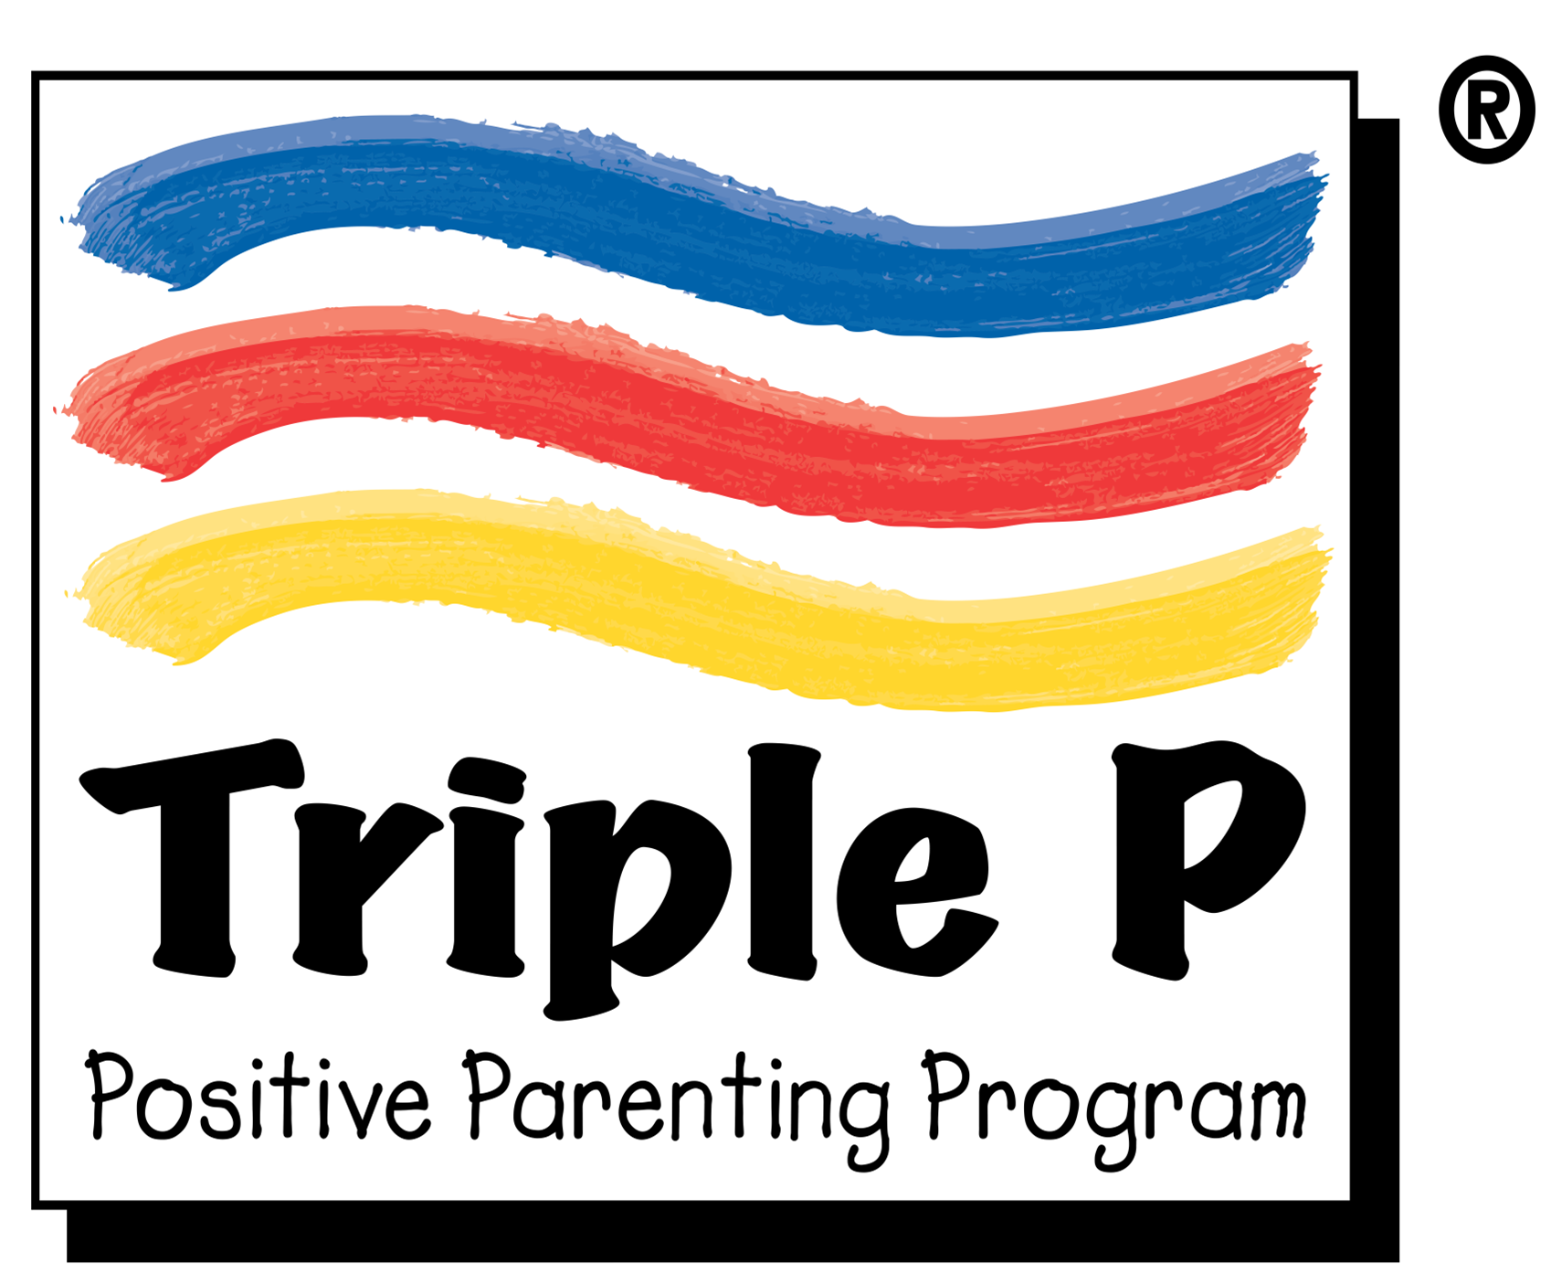
Triple P Positive Parenting Programme is an evidence-based programme that draws on social learning, cognitive behavioral and developmental theory as well as research into risk factors associated with the development of social and behavioral problems in children. It was developed by Professor Matt Sanders and others at University of Queensland, Australia.
It aims to give parents simple and practical strategies to help them build strong, healthy relationships, confidently manage their children’s behavior and prevent problems developing. The target age for the programme ranges from infants to teenagers with specific programme approaches for different age groups. The programme is currently used in more than 25 countries and has been shown to work across cultures, socio-economic groups and in many different kinds of family structures.
Standard Stepping Stones Triple P has been developed for parents of children with additional needs.
For further information, go to the web-site: http://www.triplep.net/glo-en/home/

